# CS 255 System Design Document Template

This template lays out all the different sections that you need to complete for Project Two. Each section has guidance to prompt your thinking. You will need to continually reference the interview transcript as you work to make sure that you are addressing your client’s needs. There is no required length for the final document. Instead the goal is to complete each section based on what your client’s needs are. Remove this note when you are finished, and replace all bracketed text with the relevant information.

## UML Diagrams

### UML Use Case Diagram

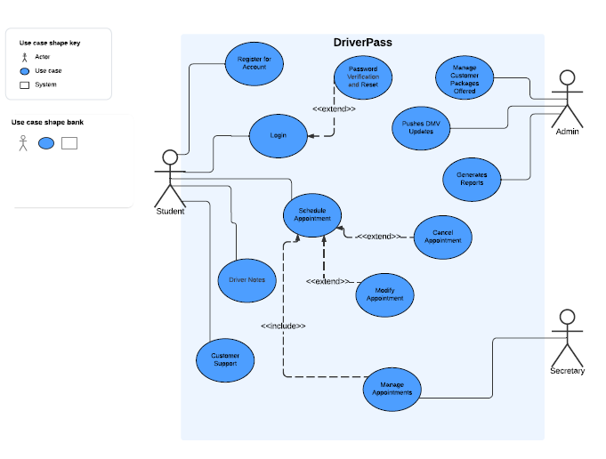

### UML Activity Diagrams

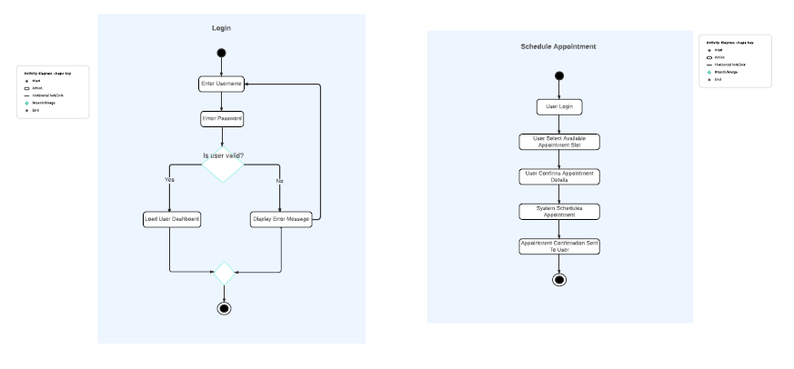

### UML Sequence Diagram

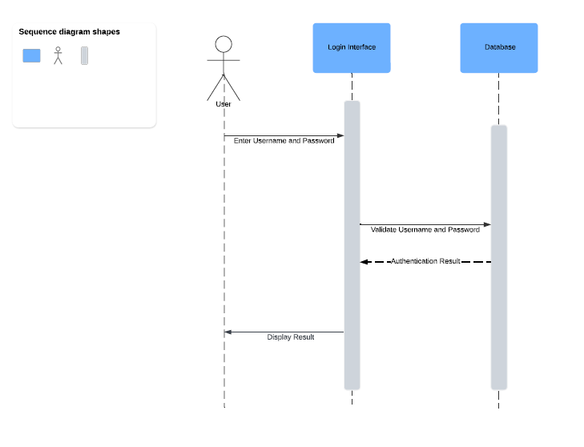

### UML Class Diagram

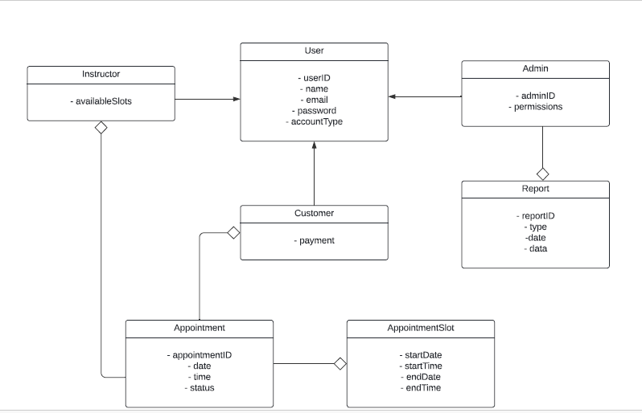

## Technical Requirements

*[Based on the diagrams you have created, describe the technical requirements of your system. These requirements should address the required hardware, software, tools, and infrastructure necessary for your system design.]*

Reviewing the functional and nonfunctional requirements from Project One and from constructing the various diagrams, we can clearly identify the technical requirements for the DriverPass system. To start, we know that the system must be scalable in order to handle a large number of users on the site at once without degrading the system’s performance. Having the DriverPass system in a cloud-based infrastructure would support the ability of the DriverPass system to be scalable to the number of users. Another technical requirement identified is the speed at which the system operates. The DriverPass system must operate quickly with minimal latency issues in order to perform at its best and to enhance the user’s experience with the system. The system must be cross-platform compatible in order to maximize the system’s use. By making the system a web-based system, all users would have access to the system rather than restricting the system to platform specific devices. For privacy purposes, the system must be secure which requires data encryption. The system will communicate to the users using SSL protocols in order to protect the user’s personal information, test results and banking information. There also is a need for authentication as we want to ensure the correct user is accessing the account. The system needs to be adaptable to allow for the administrators to add, change and remove users without changing the system code, causing system downtime. The system also needs to be adaptable in order to handle updates such as the DMV updates. Lastly, the system must be reliable in order to handle a worst-case scenario such as a system crash. The system must support backups in order to ensure that if the system were to crash, the data can be retrieved and aid in getting the system back up and running with minimal impact.